## horizontal line

**Book Store Management System**



## horizontal line

## 

**INTRODUCTION**

Book Store Management System is the web application to automate all kinds of operations in the book store.The purpose of this project is to manage the books in the book store. Generally, it includes the Order Processing, Stock Management and records of the book. Here we are trying to develop such a type of system which provides the automation for a bookstore. That means a shop which has a type of system which provides the facility to the customers to purchase and get information about the books from the shop without any complexity.

Language used in front end: **PYTHON**

Language used in back end**: MYSQL**

Features used in MYSQL**: DML & DDL Statements, Triggers, Stored Procedures, Function, Views, Joins.**

**OBJECTIVES**

* To search the records more efficiently and in a fast manner in comparison to manual search.
* To assure that we have a proper record of the selling of the books so that we can limit our books stock according to that.
* To reduce the cost and time of the shopkeeper who will take care of the shop.
* It keeps a database of book details, sales record, customer record, publisher record.
* To create a consistent and sufficient database system by updating the stock whenever it goes below the threshold value.

**DESIGNS (CONCEPTUAL)**

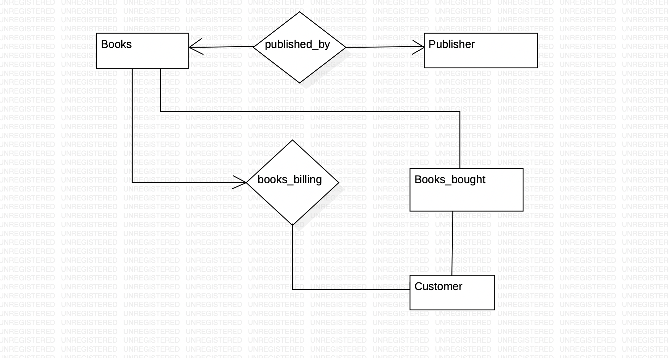

Figure. 1

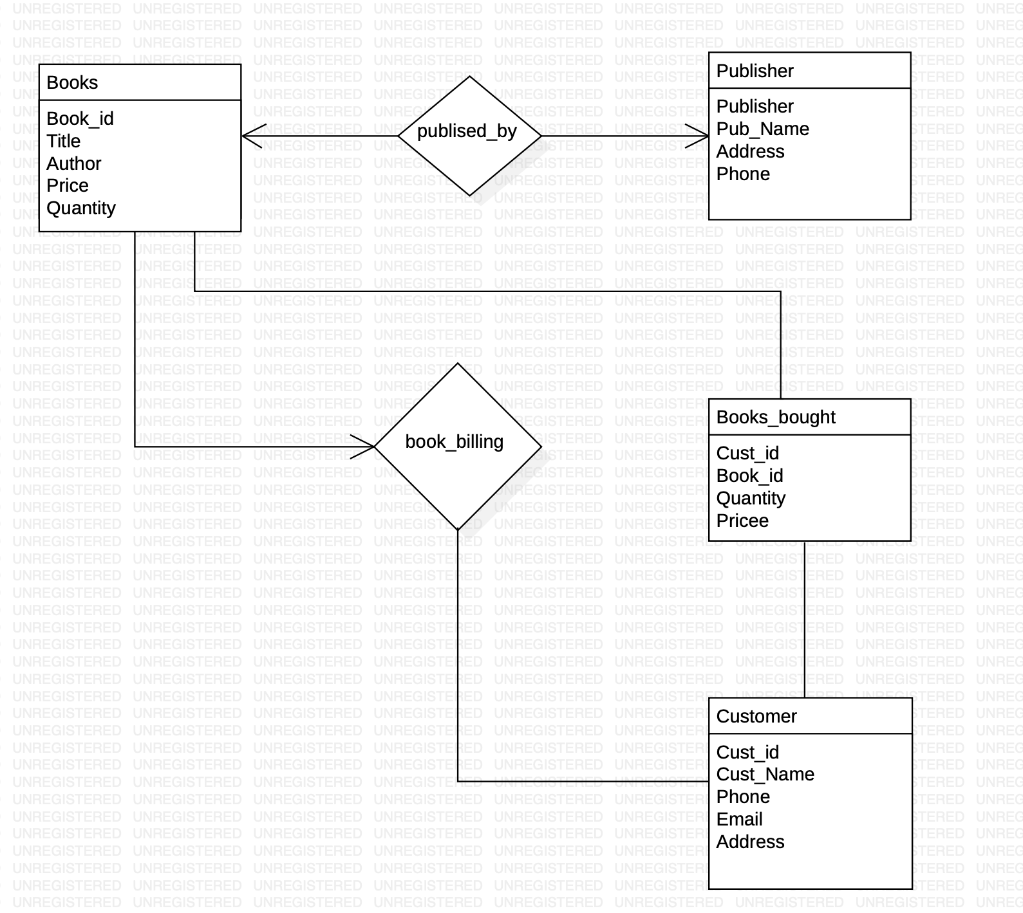

Figure. 2

**(LOGICAL)**

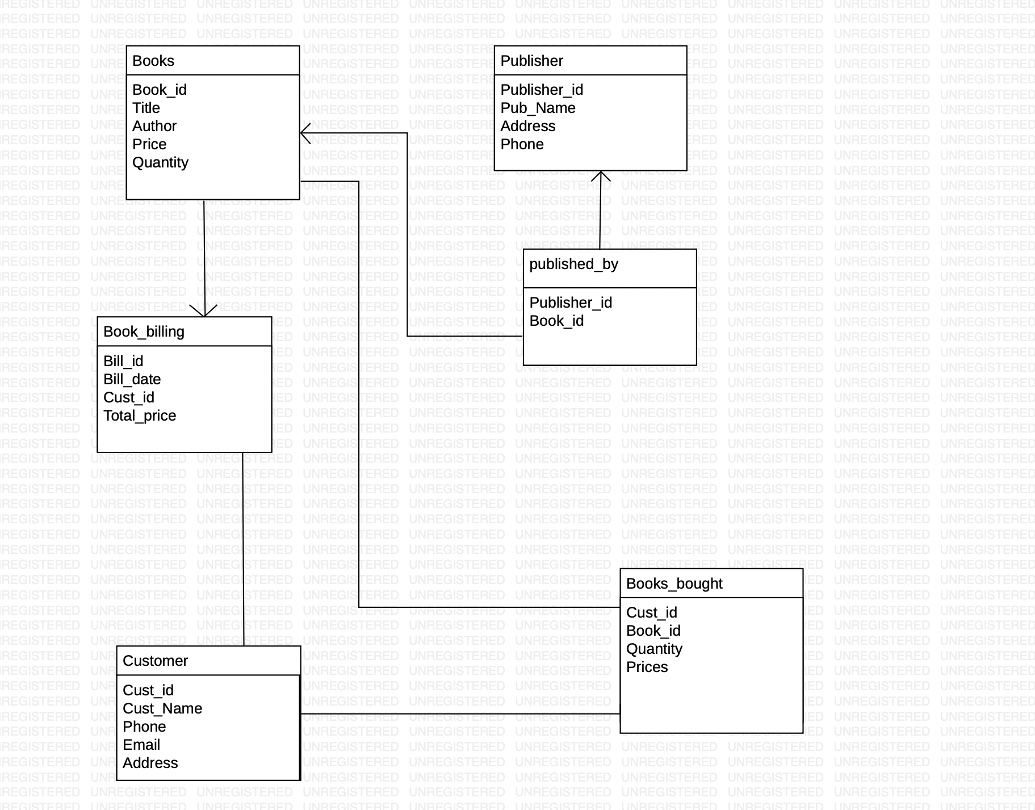

Figure. 3

**ER DIAGRAM**

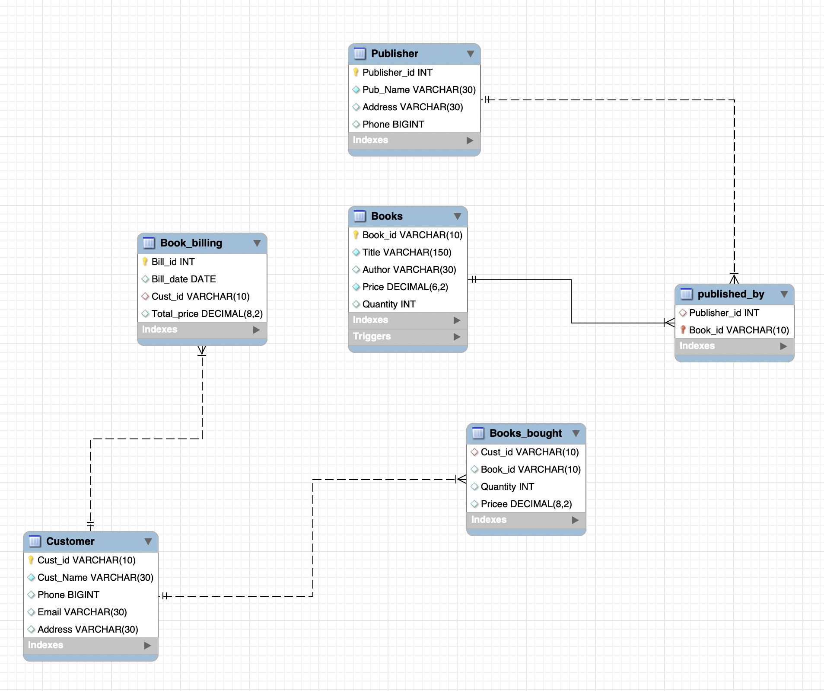

Figure. 4

**CREATION OF DATABASE**

create database bookstore;

use bookstore;

Create table **Books**(

Book_id varchar(10) primary key,

Title varchar(150) not null,

Author varchar (30),

Price numeric(6,2) not null,

Quantity int(4));

Create table **Books_bought**(

Cust_id varchar(10),

Book_id varchar(10),

Quantity int(3),

Price numeric(8,2), foreign key (Cust_id) references Customer (Cust_id) on delete cascade);

Create table **Book_billing**(

Bill_id int auto_increment primary key,

Bill_date date,

Cust_id varchar(10) ,

Total_Quantity int(5),

Total_price numeric(8,2), foreign key (Cust_id) references Customer (Cust_id) on delete cascade);

Create table **Customer**(

Cust_id varchar(10) primary key,

Cust_Name varchar(30) not null,

Phone bigint(20) ,

Email varchar(30) ,

Address varchar(30));

Create table **Publisher**(

Publisher_id int(5) primary key,

Pub_Name varchar(30) not null,

Address varchar(30),

Phone bigint(20));

Create table **published_by**(

Publisher_id int(5),

Book_id varchar(10) primary key);

Alter table published_by add Foreign key (Publisher_id) references Publisher (Publisher_id) on delete cascade;

Alter table published_by add Foreign key (Book_id) references Books (Book_id) on delete cascade;

**INSERTION VALUE INTO TABLES**

**BOOKS TABLE**

=>insert into Books values ('BK01','Harry Potter and the Half-Blood Prince (Harry Potter #6)','J.K. Rowling','299',15);

=>insert into Books values ('BK02','Harry Potter and the Order of the Phoenix (Harry Potter #5)','J.K. Rowling','299',17);

=>insert into Books values ('BK03','Harry Potter and the Chamber of Secrets (Harry Potter #2)','J.K. Rowling','299',16);

=>insert into Books values ('BK04','Harry Potter and the Prisoner of Azkaban (Harry Potter #3)','J.K. Rowling','299',18);

=>insert into Books values ('BK05','Harry Potter Boxed Set Books 1-5 (Harry Potter #1-5)',

'J.K. Rowling','1199',20);

**PUBLISHER TABLE**

=>insert into Publisher values ( 1001, 'Scholastic Inc', 'Bangalore', 9484845487);

=>insert into Publisher values ( 1002, 'Nimble Books', 'Hyderabad', 9484845400);

=>insert into Publisher values ( 1003, 'Gramercy Books', 'Kolkata', 9484845411);

=>insert into Publisher values ( 1004, 'DelRey Books', 'Chennai', 9484845227);

=>insert into Publisher values ( 1005, 'Crown', 'Bangalore', 9484844487);

**PUBLISHED_BY TABLE**

=>insert into published_by values( 1001,'BK01');

=>insert into published_by values( 1001,'BK02');

=>insert into published_by values( 1001,'BK03');

=>insert into published_by values( 1001,'BK04');

=>insert into published_by values( 1001,'BK05');

**TABLES**

> select * from **Books**;

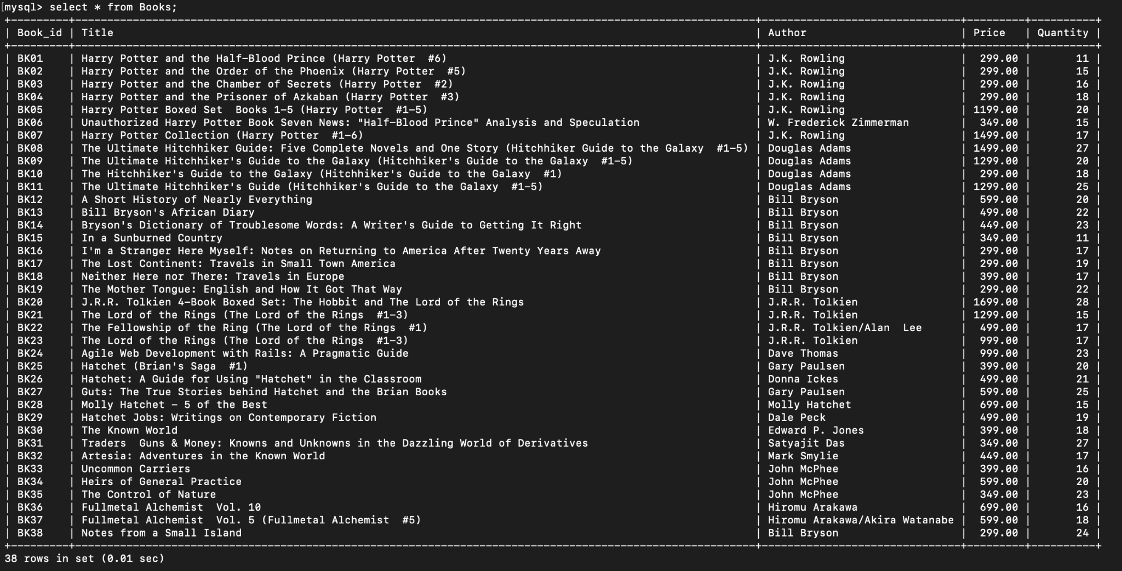

Figure. 5

> select * from **Publisher**;

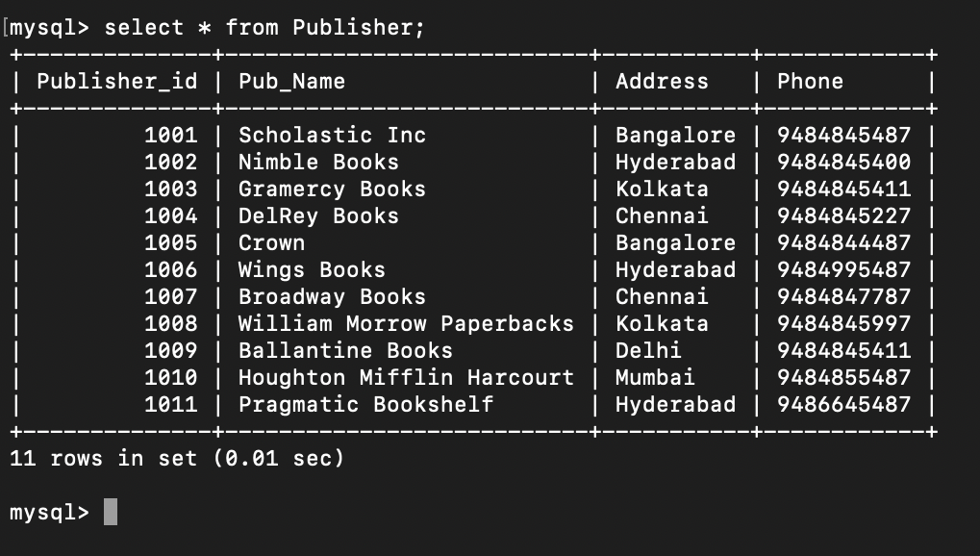

Figure. 6

> select * from **Customer**; (Automated insertion values)

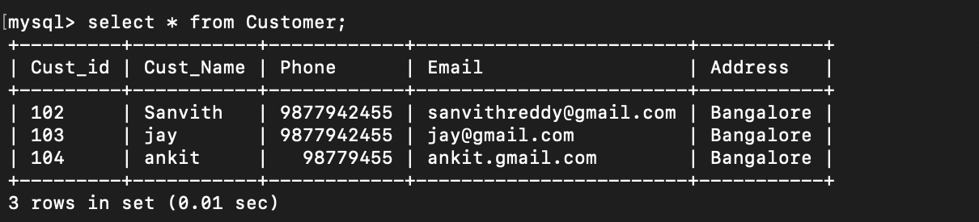

Figure. 7

> select * from **Books_bought**; (Automated insertion values)

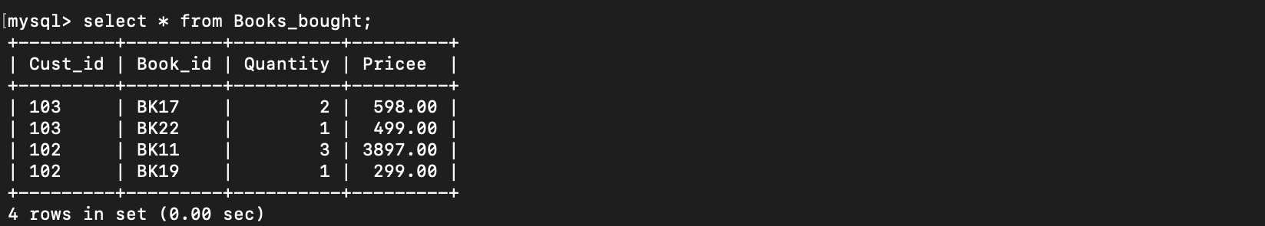

Figure. 8

> select * from **Book_billing;** (Automated insertion values)

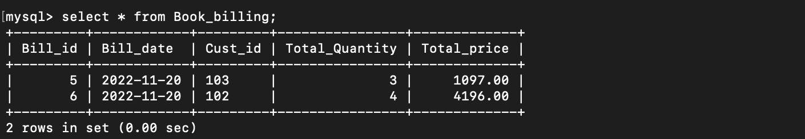

Figure. 9

> select * from **Published_by**;

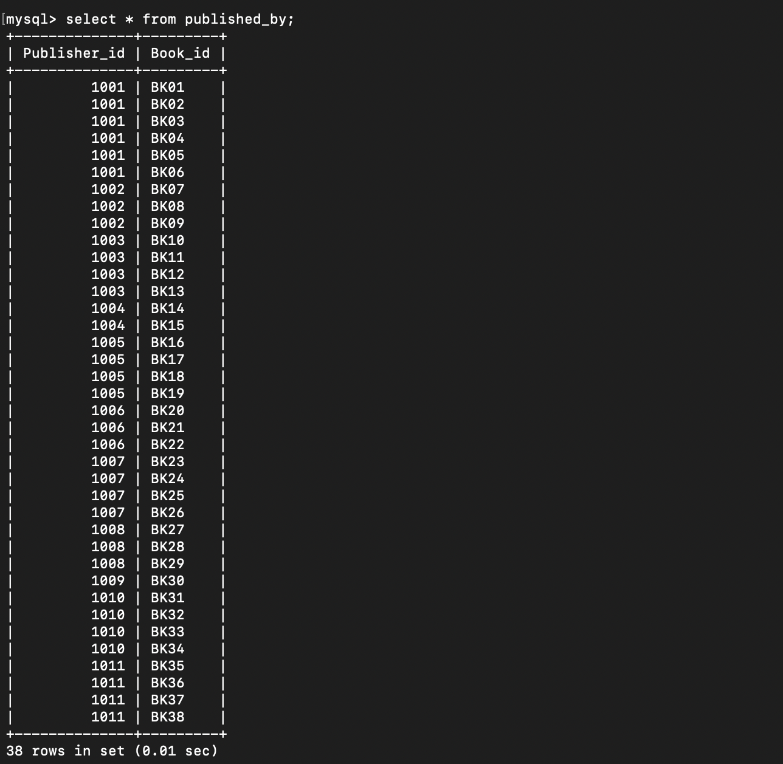

Figure. 10

**IMPLEMENTATION (SAMPLE QUERIES)**

**Calculate the total number of books published by each customer.**

> select Publisher_id ,Pub_Name, COUNT(book_id) as count from published_by natural join publisher group by Publisher_id order by count desc ;

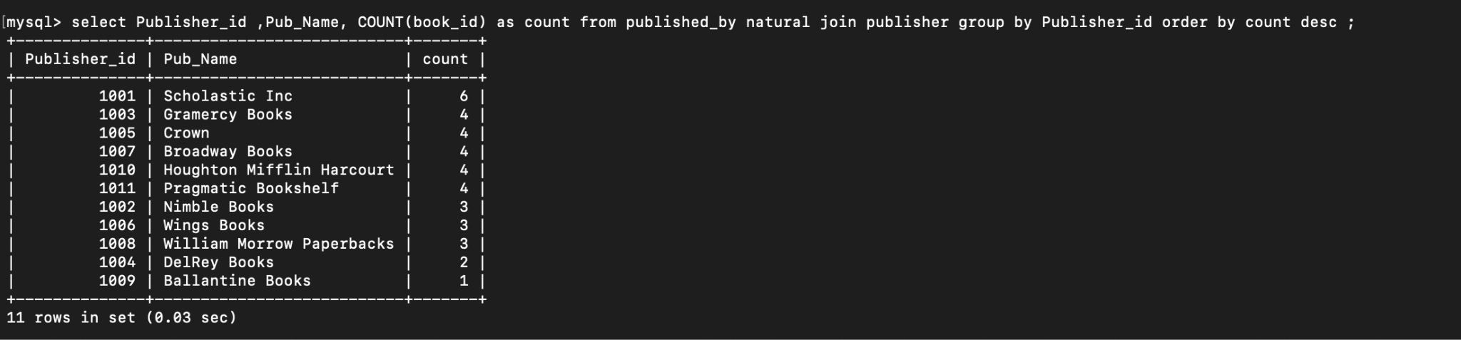

Figure. 11

**Find the publisher name and id who have published maximum number of books among all the publishers.**

> select Publisher_id ,Pub_Name, COUNT(book_id) as count from published_by natural join publisher group by Publisher_id order by count desc limit 1;

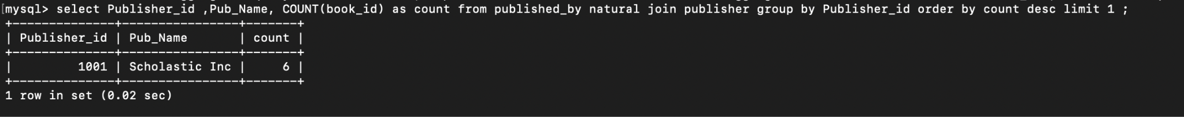

Figure. 12

**Find the publisher name and id who have published minimum number of books among all the publishers.**

> select Publisher_id ,Pub_Name, COUNT(book_id) as count from published_by natural join publisher group by Publisher_id order by count asc limit 1 ;



Figure. 13

**Retrieve the number of books written by J.K. Rowling.**

> select Author, count(book_id) from books where Author = 'J.K. Rowling';

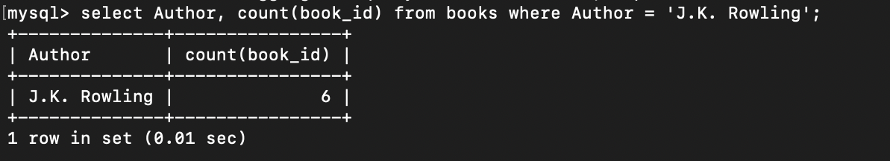

Figure. 14

**Find the author who have written the maximum number of books among all the authors.**

> select Author , count(book_id) as count from books group by Author order by count desc limit 1;

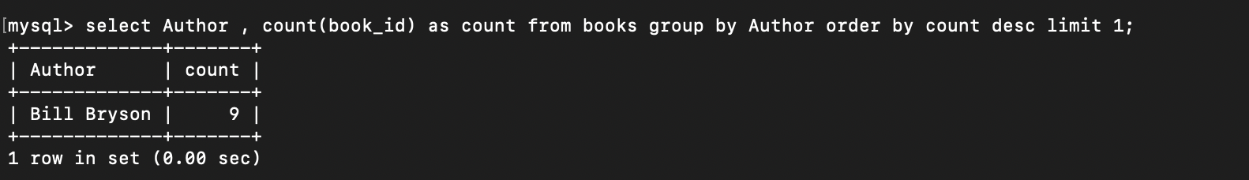

Figure. 15

**Find the author who have written the minimum number of books among all the authors.**

>select Author , count(book_id) as count from books group by Author order by count desc limit 1;

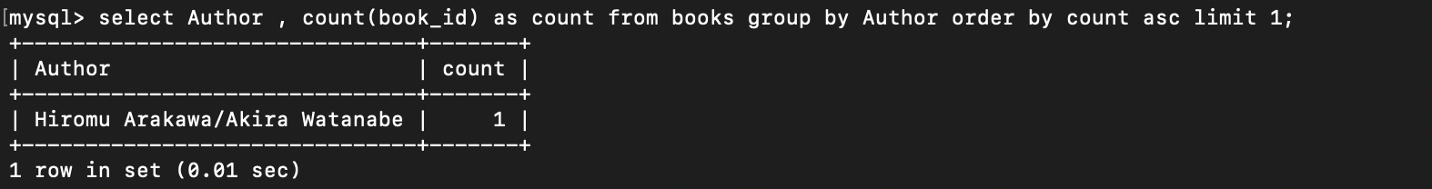

Figure. 16

**Retrieve the book_id and the title of the book having maximum price;**

> select Book_id,Title,MAX(Price) from Books group by Book_id order by MAX(Price) desc limit 1;



Figure. 17

**FEATURES**

**1. RELATIONSHIP ➖**

* We’ve used the ‘book_billing’ relationship entity set to relate the entity sets ‘books’ and ‘Books_bought’ such that the relationship tells us <which books> have been bought by the <customer> and the <id of the bill> that has been generated along with the ‘total_ price’ to be paid.
* We’ve also used the ‘published_by’ relationship entity set to relate entity sets ‘books’ and ‘publisher’ such that the relationship tells us <which books> have been published by <which publisher> or which publisher published which books.

**2. STORED PROCEDURES ➖**

>>> CREATE DEFINER=`root`@`localhost` PROCEDURE  **generate_bill**(IN custid varchar(10) , IN bookid varchar(10) , IN booksbought int(4))

BEGIN

declare totprice numeric(8,2) default 0;

declare bookprice numeric(8,2) default 0;

set bookprice = (select price from Books where Book_id = bookid);

set totprice = bookprice * booksbought;

update Books set Quantity = Quantity - booksbought where Book_id = bookid;

insert into Books_bought(Cust_id , Book_id , Quantity , Pricee) values (custid , bookid ,booksbought , totprice);

select * from Books_bought;

END

* A stored procedure **‘generate_billl’** has been implemented to the database system to calculate the price of the each book bought by the respective customer in which we took the following input parameters:
  + ‘cust_id’
  + ‘Book_id’
  + ‘Quantity_bought’ respectively.

– This procedure will insert the following values in ‘Books_bought’ table

* Cust_id
* Book_id
* Quantity_bought_per_book
* And the price calculated

– Furthermore, the number of books bought by the customer are subtracted from the ‘quantity in books’ to maintain the database record and make it <consistent>.

>>> CREATE DEFINER=`root`@`localhost` PROCEDURE **GRAND_BILL**(IN custtidd varchar(10))

BEGIN

declare z numeric(8,2) default 0;

declare billdate date ;

declare x numeric(8,2) default 0;

select sum(Quantity) into x from Books_bought where Cust_id = custtidd;

set billdate = curdate();

set z = GENERATE_BILL2(custtidd);

insert into Book_billing(Bill_date , Cust_id ,Total_Quantity,Total_price) values (billdate , custtidd ,x, z);

select * from Book_billing;

END

* Another stored procedure ‘**GRAND BILL’** has been implemented in the database to calculate the total number of books bought by customers. And the Total_price of the bill is fetched by the function **‘GENERATE BILL2’**

– This procedure will insert the following values in the book_billing table

* Bill_id
* Bill_date
* Cust_id
* Total_price

– We’ve implemented auto_increment function to auto generate the bill_id and also <curdate()> function to find the date on which the books were bought by the customer.

**BOTH THE STORED PROCEDURES ARE MAPPED TO THERE MENUS IN THE FRONT END THAT IS THE CALLING OF PROCEDURE IS DONE IN THE FRONT END**.

**3. FUNCTION ➖**

CREATE DEFINER=`root`@`localhost` FUNCTION **GENERATE_BILL2** (custidd varchar(10)) RETURNS decimal(10,0)

DETERMINISTIC

BEGIN

declare x numeric(8,2) default 0;

select sum(Pricee) into x from Books_bought where Cust_id = custidd;

RETURN x;

END

* A function named **‘GENERATE_BILL2**’ calculates the total bill amount for every book that is bought by customer
* This function is flexible and takes into account the quantity and also aggregates bill amount for different books that are bought by the customer in the same session.

**4. ‘BEFORE_UPDATE_ON_TRIGGER’ ➖**

CREATE DEFINER=`root`@`localhost` TRIGGER **before_update_books** BEFORE UPDATE ON Books FOR EACH ROW BEGIN

if new.Quantity < 7 then set new.Quantity = new.Quantity + 20;

end if;

END

* A trigger **‘before_update_books’** has been created which is executed for the event <before update on ‘books’>

The trigger adds 20 books to the updated quantity in ‘books’ if the updated quantity becomes less than 7 after the update.

**5. VIEWS ➖**

>>> create view **finalbill** as select Cust_name , Cust_id , Bill_id , Bill_date , Total_Quantity , Total_price from Book_billing natural join Customer;

* A view has been created called **‘Final_bill’** in which we will get the details of Cust_name, Cust_id, Bill_id, Bill_date, Total_Quantity,Total_price.

> select * from finalbill where Cust_id = ‘102’;

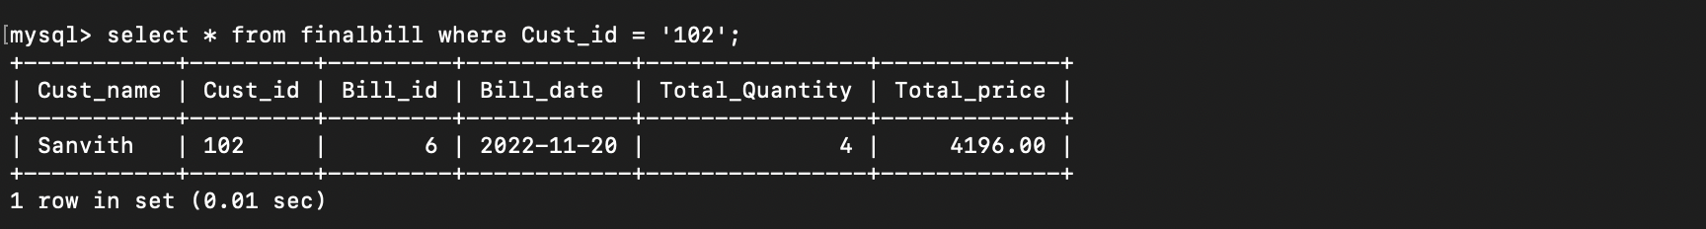

Figure. 18

> select * from finalbill where Cust_id = ‘103’;

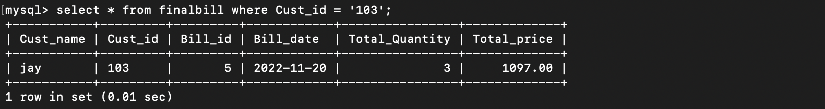

Figure. 19

**DATABASE CONNECTION USING PYTHON MYSQL CONNECTER**





Figure. 20

**FRONTEND (PYTHON)**

**–MENU DISPLAYED (Register customer is the default page)**

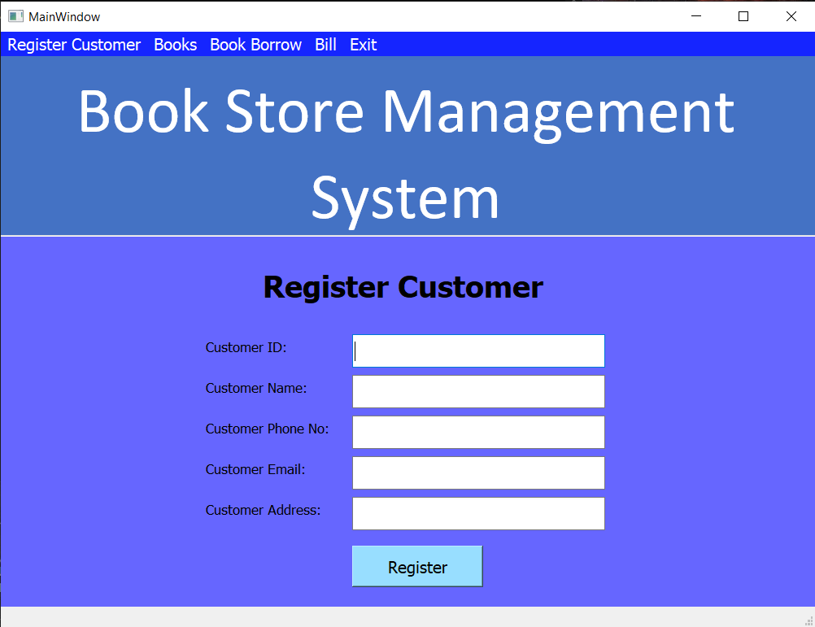

Figure. 21

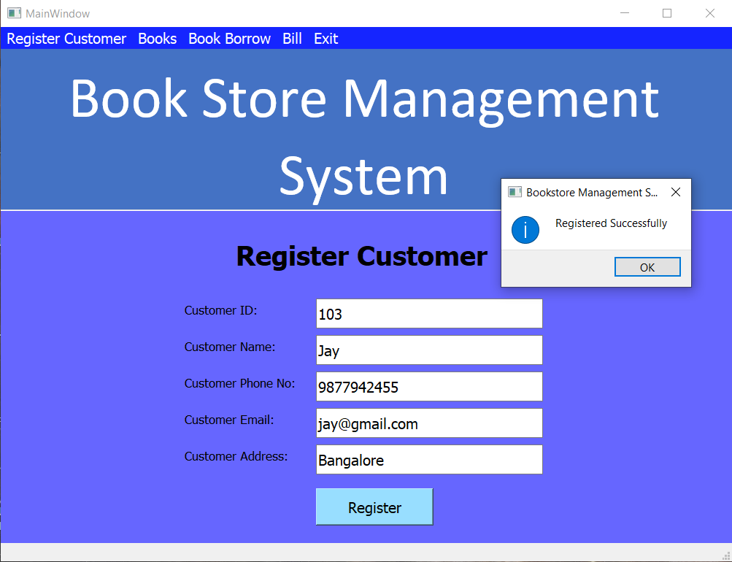

Figure. 22

**– Customer has been registered and the desired data is inserted into the customer table**

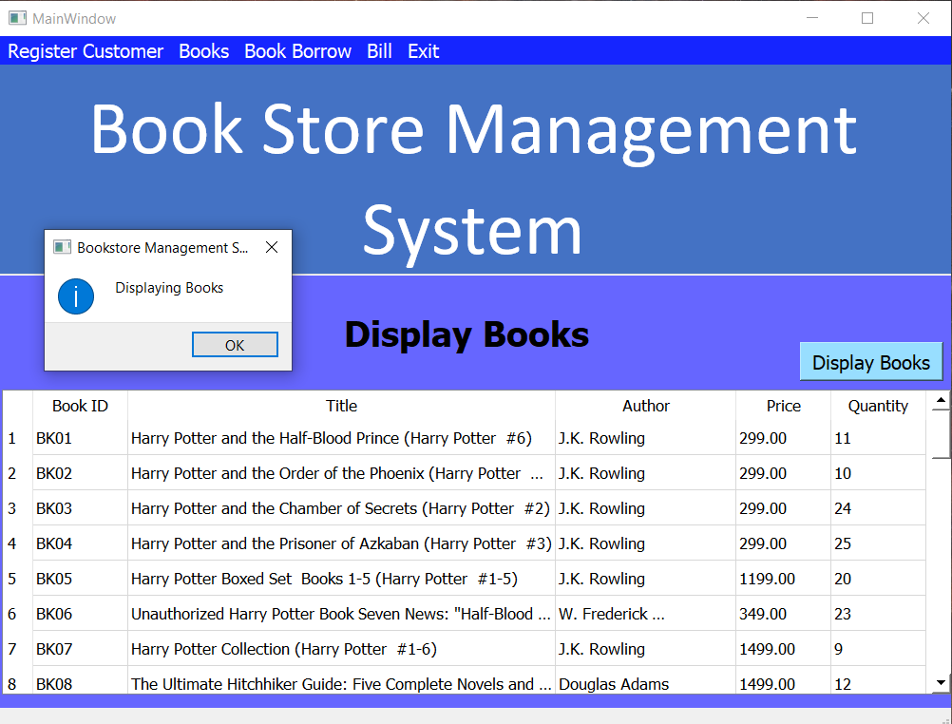

Figure. 23

**– BOOK MENU HAS BEEN DISPLAYED**

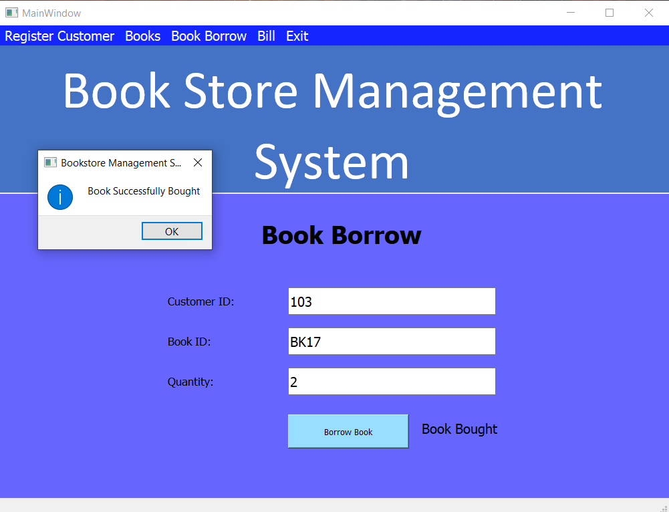

Figure. 24

**– Book has been bought and the desired data is inserted into the Book_bought table**

**– Book has been bought and the desired data is inserted into the Book_bought table**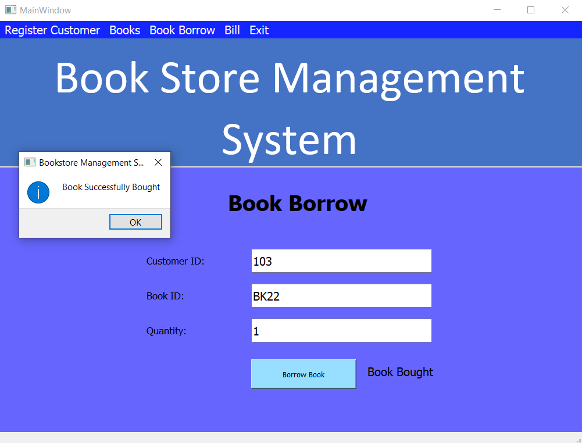

Figure. 25

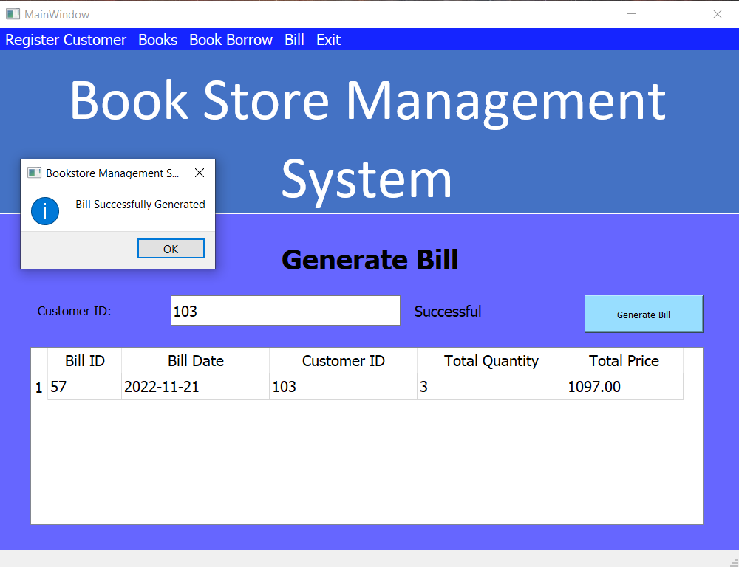

Figure. 26

**– The bill has been generated in the database and the values are inserted into the Book_billing table.**

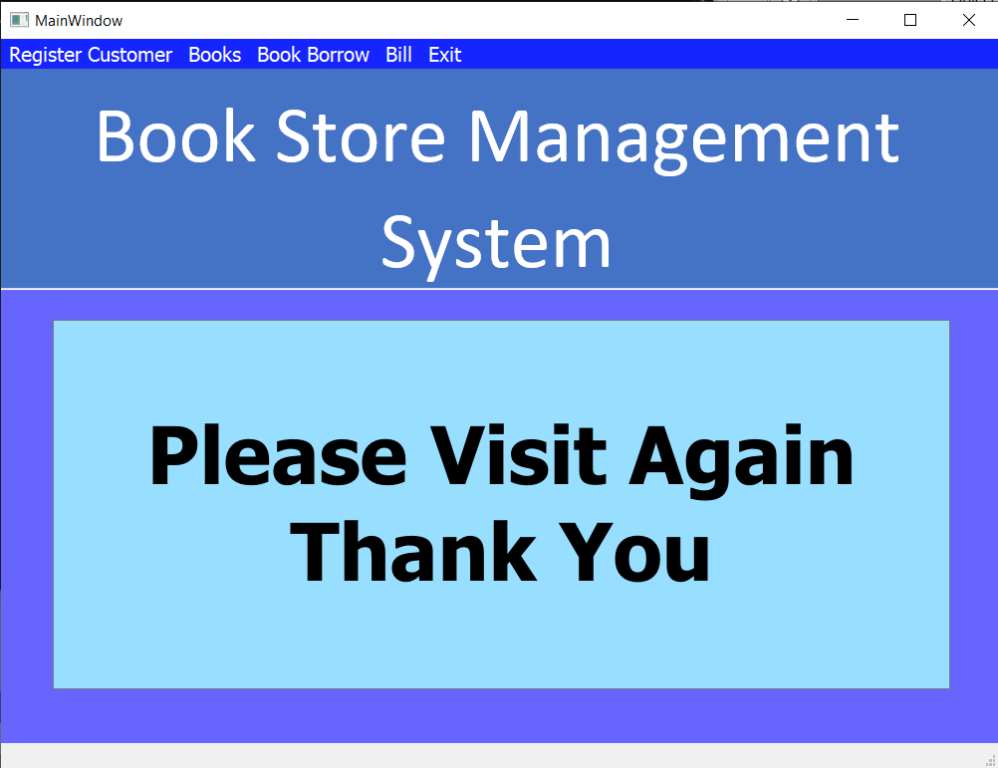

Figure. 27

**CONCLUSION**

Book store management system is an attempt to overcome the time consuming process of locating, reserving and purchasing quality reading materials available in the shop. Automated book shop solutions provide an easy way of searching and purchasing the books. It’s worth analyzing and identifying the benefits as it would directly influence the productivity of the shop.

